In our modern era we have developed and innovate technology immensely that we x50 billion computing power from the last 50 years since the 1970s.

Computing Project Proposal

Raspberry Pi Tiny, Portable, and Powerful PC

Michael Inso – ACCP

APTECH QATAR



Statement and Confirmation of Own Work

|  |
| --- |
| ***A signed copy of this form must be submitted with every assignment.***  ***If the statement is missing your work may not be marked.*** |

Student Declaration

I confirm the following details:

|  |  |
| --- | --- |
| Candidate Name: | MICHAEL G. INSO |
| Candidate ID Number: | 00188933 |
| Qualification: | L5DC |
| Unit: | COMPUTING PROJECT |
| Centre: | APTECH QATAR |
| I have read and understood both NCC Education’s *Academic Misconduct Policy* and the *Referencing and Bibliographies* document. To the best of my knowledge my work has been accurately referenced and all sources cited correctly.  I confirm that this is my own work and that I have not colluded or plagiarised any part of it. | |
| Candidate Signature: |  |
| Date: | 4/14/2021 |

**OPS020_dec16_Candidate+Statement+of+Own+Work.doc** 

**OPS020_dec16_Candidate+Statement+of+Own+Work.doc**

Acknowledgement3

Introduction4

1. Raspberry Pi 4 Model B 8GxBx xRAMx + xCasex + xFanx + xHeatxSinkx + xPowerx xAdapterx + 32x xFATx 32 xGB SD xCard + xMicrox xHDMIx xCablex for xRPIx x4Bx 5

Summary6

References7

Bibliography8

Figures

Figure 1 Raspberry Pi 4 Model B 8GxBx xRAMx + xCasex + xFanx + xHeatxSinkx + xPowerx xAdapterx + 32x xFATx 32 xGB SD xCard + xMicrox xHDMIx xCablex for xRPIx x4Bx 6

**Acknowledgment**

This project would not have been possible with a lot of dedicated special individuals putting their hearts, trust, and faith in me helping me to persevere and be persistent.

I would like to express my special thanks of gratitude to Aptech Qatar Education Centre who gave the amazing opportunity to do this strenuous project on the topic of Project Computing for NCC education, which also helped me in doing a lot of exploration and investigation and I acquired so many new knowledge and skills about Raspberry Pi, Nvidia Jetson Nano, and Asus Tinker Board.

Secondly, I would also like to thank my family, friends, and relatives who still give me assistance, comradery, sponsorship, and accommodation even I’m already a capable adult they helped me a lot in completing this project within a limited duration of time.

**Introduction**

In this project, we will be building and assembling xRaspberry xPi s4 8gb model B. It is the most currently powerful xRaspberry xPis costing only $75. We can do a lot of things with it from being just a regular Linux pc, server, VPN, and pen-testing, etc. And to more sophisticated projects like Artificial Intelligence, Machine Learning, and Deep Learning, etc. here is the list of projects for <https://projects.raspberrypi.org/en>. Alternatively, we can use powerful chips like Nvidia Jetson Nano or Asus Tinker box for more sophisticated projects. In the project, we will use the Debian Linux/GNU (Raspbian) Operating System. We will be formatting our SD card as Fat32 since xRaspberryx xPi’sx xbootloaderx, xbuiltx xintox the GPU and non-updatable, only has support reading from FAT filesystems (both FAT16 and FAT32), and is unable to boot from an exFat and NTFS filesystem. We will be setting up xNews xOutx xofx xBoxs xSoftwarex (xNOOBSx) xforx anx xeasyx xOperatingx xSystemx xinstallationx in our xRaspberryx xPix s4x x8gb models Bx.

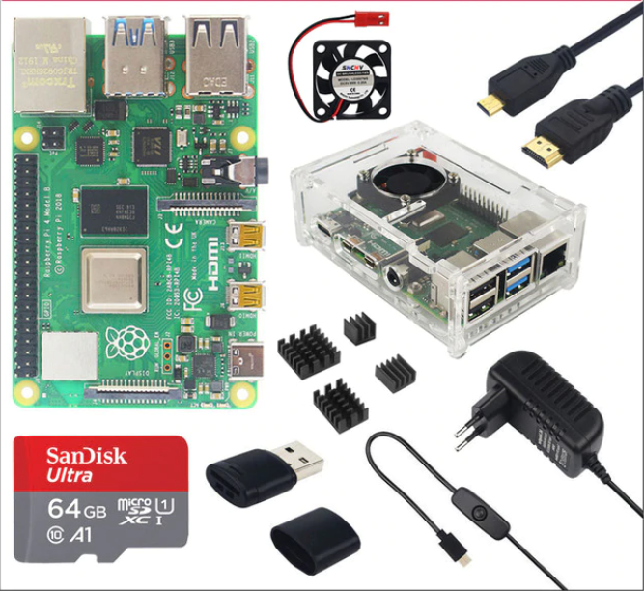

# Figure 1: a.) xRaspberrysx xPix x4x xModelx xBx x8GxBx xRAMx + xCasex + xFanx + xHeatxSinkx + xPowerx xAdapterx + 32x xFATx 32 xGB SD xCard + xMicrox xHDMIx xCablex for xRPIx x4Bx

1. Specification of Raspberry Pi 4 8gb model B

* Broadcom xBC_M27_11, xQuad_corex_ xCortex-A_72x (xARM_v8x) x64-bit SoC_@_2.5GHz
* x8_GB xLPDDR_4-3200x SD_RAM
* x2.4x_GHz and x5.0_GHz _IEEE _x802._11acx wireless, Bluetooth x5.0_, BLE
* xGigabit _xEthernet
* x2_USB _x3.0 ports; x2_xUSBx _x2.0x xportsx.
* xRaspberryx sxPix standard _x40 xpinx sxGPIO_ headerx (xfullyx xbackwards xcompatiblex with xpreviousx xboardsx)x
* _x2 xmicro_xHDMI ports (up to x_4k_p60 supported)
* x2-xlanex_MxIPI_xDSIx xdisplay portx
* x2-xlanex_xMIPIx_xCSIx xcamera xport
* x4_xpolex x_xstereox_audiox and-xcompositex-xvideo-xport
* _xH.265x (x4k_p60 xdecode), xH264 (x1080_p60 decode, x1080_p30 encode)
* OpenGL_ES_x3.0x xgraphics
* xMicrox_xSDx xcard xslot xfor xloading xoperating xsystem xand xdata xstorage
* x5V_xDC xvia _xUSB-C xconnector (xminimum x3A_*)
* x5V_xDC xvia _xGPIO xheader (xminimum x3A_*)
* xPower_over_Ethernet (xPoE) xenabled (xrequires_xseparate _xPoE _xHAT)
* xOperating temperature: x0 – x50 xdegrees_C_ambient

* xA xgood xquality x_2.5A xpower xsupply xcan xbe xused xif xdownstream xUSB xperipherals xconsume xless xthan x_500mA inx xtotal.

1. Summary

* In our modern era, we have developed and innovate technology immensely that we x50 billion computing power from the last 50 years since the 1970s.
* There’s a lot of Raspberry Pi alternatives available in the market.
* Raspberry Pi can have a lot of uses from regular Linux pc, server, VPN, and pen-testing, etc. And to more sophisticated projects like Artificial Intelligence, Machine Learning, and Deep Learning, etc. here is the list of projects for <https://projects.raspberrypi.org/en>.
* Computers got more portable and compact in the last 57 years since 1943 first computer ENIAC invention occupying 1x,800 squarex xfeet and xused xabout 18,00 xvacuum xtubes, xweighing xalmost x50 tonsx.
* In upcoming future, additional powerful single-board computers will have further capabilities than our current and modern PCs. NVIDIA TITAN V and AMD Radeon RX 5700 likely will have supports for it.

**References:**

**Bibliography**

<https://www.raspberrypi.org/>

<https://www.sraspberrypi.org/products/raspberry-pi-4-model-b/specifications/>

<https://www.sraspberrypi.org/products/raspberry-pi-4-model-b/?resellerType=home>

<https://en.wikipedia.org/wiki/Computer#First_computing_device>

https://www.slivescience. /20718-computer-history.html

Statistics:

Pages: 24

Words: 1,825

Characters (no spaces): 9,164

Characters (with spaces): 10,959

Paragraphs: 127

Lines: 554